# **CSC2402 Assignment 2**

# **By Peter Compton – U1077579**

## **Output Screenshots:**

## **Question 1**

Error processing

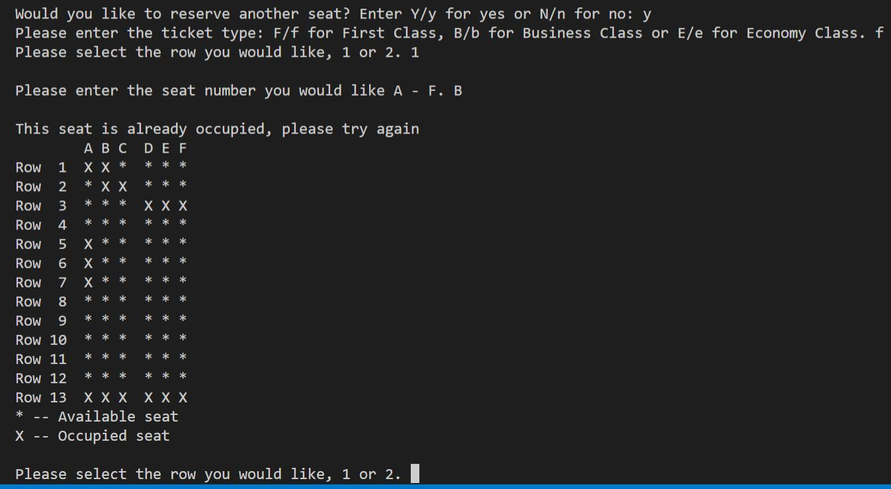

Final layout

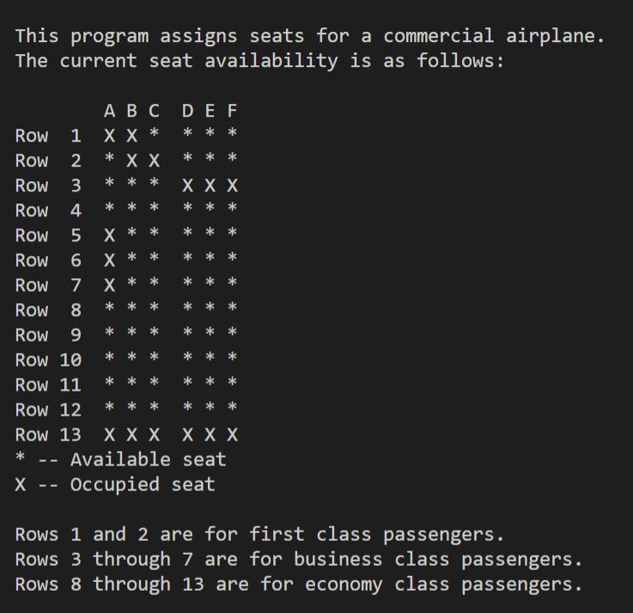

## **Question 2**

Input of 20 Numbers

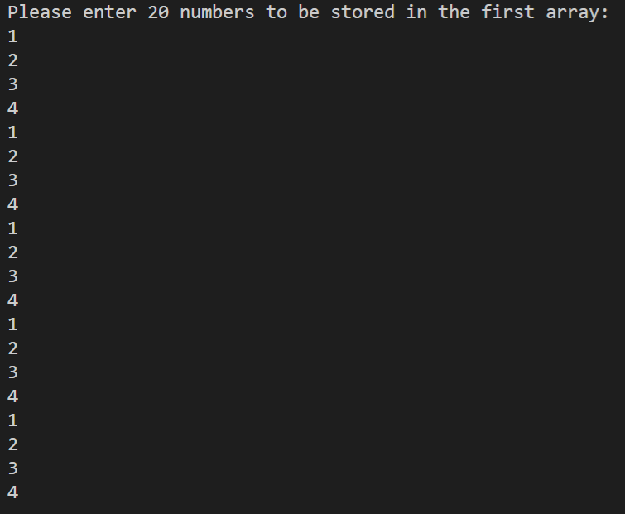

Alpha, Beta and double matrix

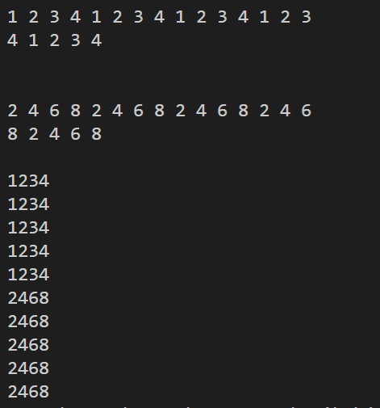

**Question 3**

